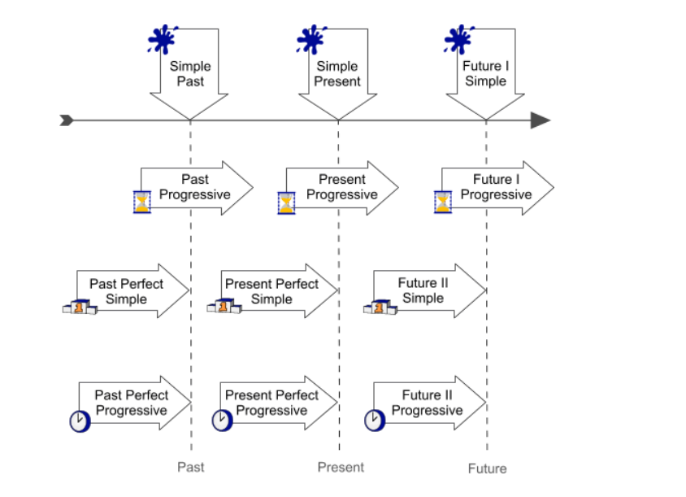

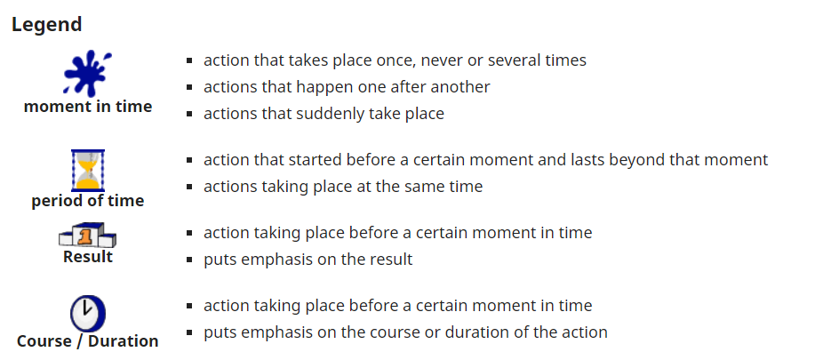

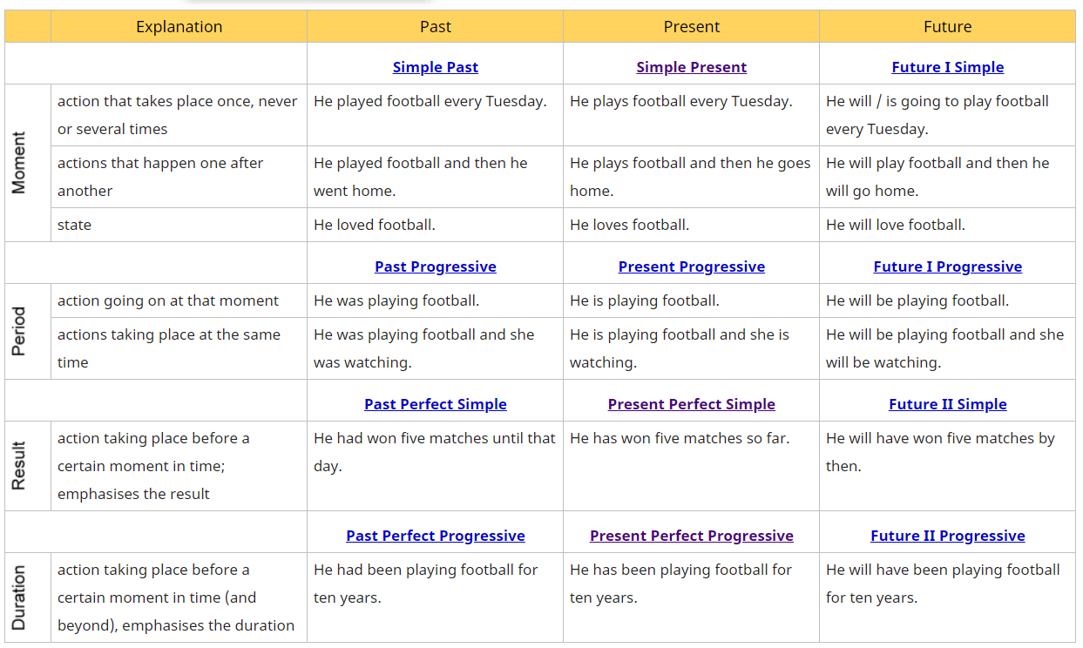

**State verbs generally fall into 4 groups:**

**Emotion**: love, hate, want, need

**Possession**: have, own, want, belong

**Sense**: see, hear, smell, seem

**Thought**: know, believe, remember

